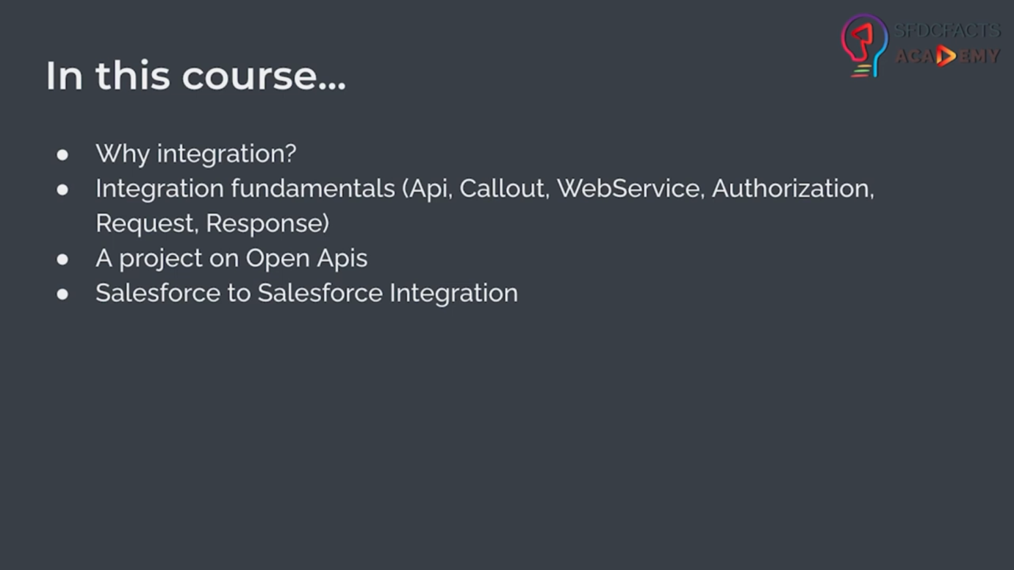

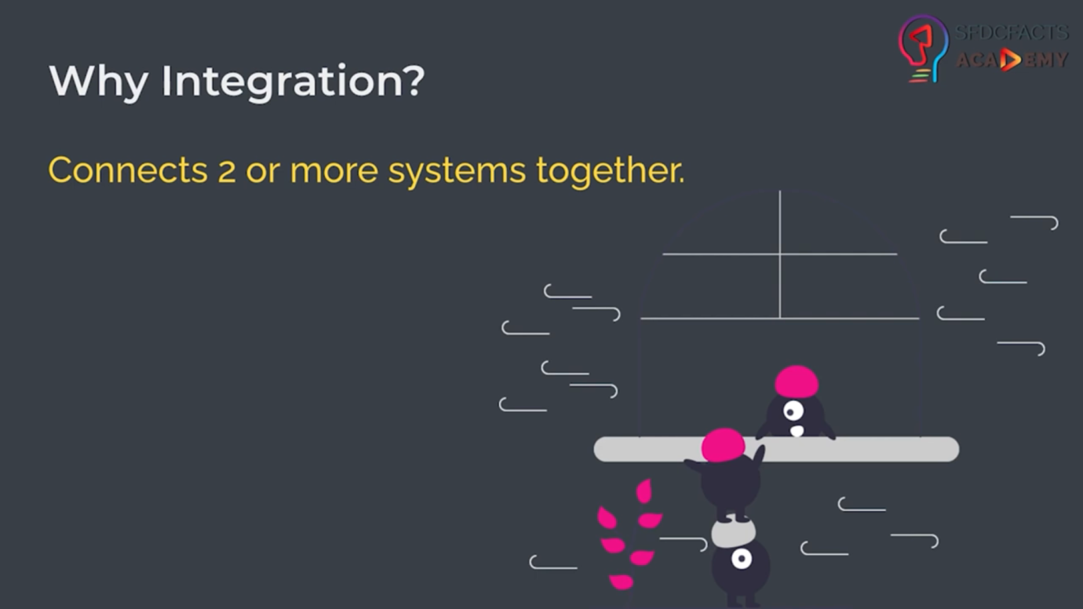

# Integration Flow and Terminologies (API, Endpoint, Web service, Request, Response, Authorization, Callout):

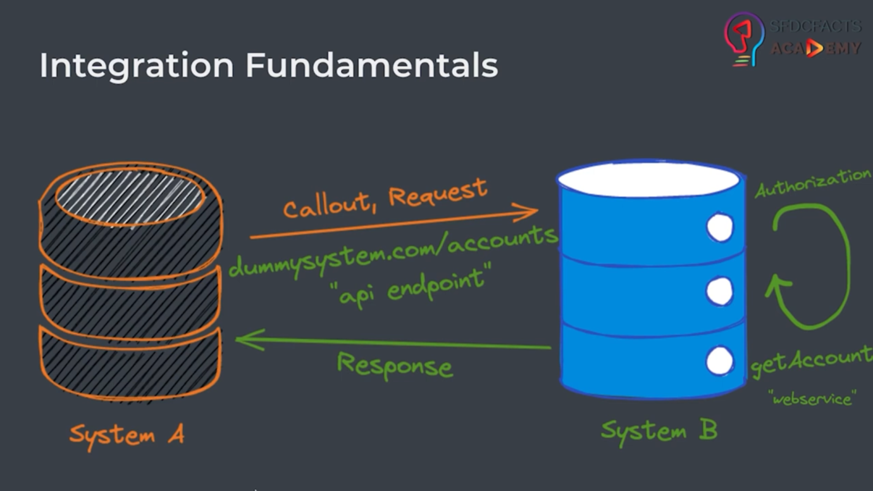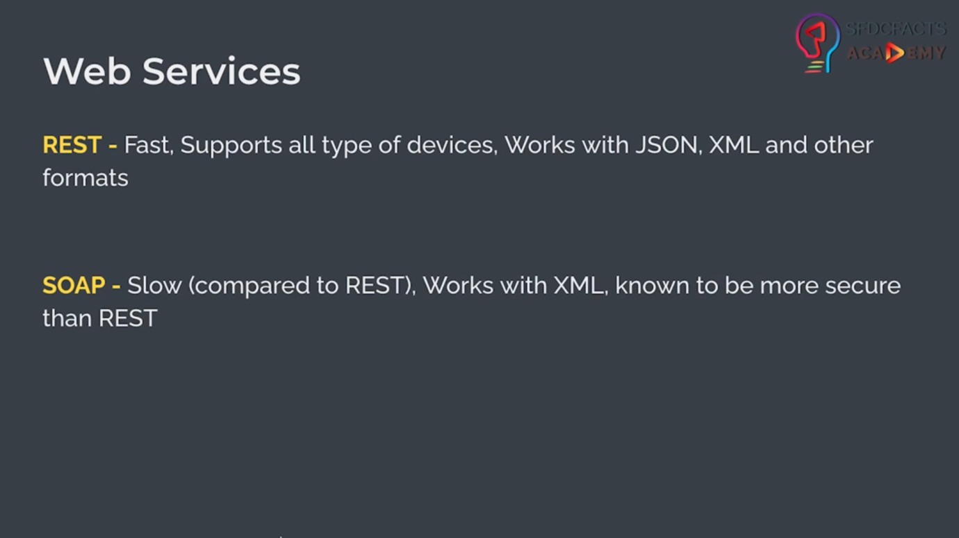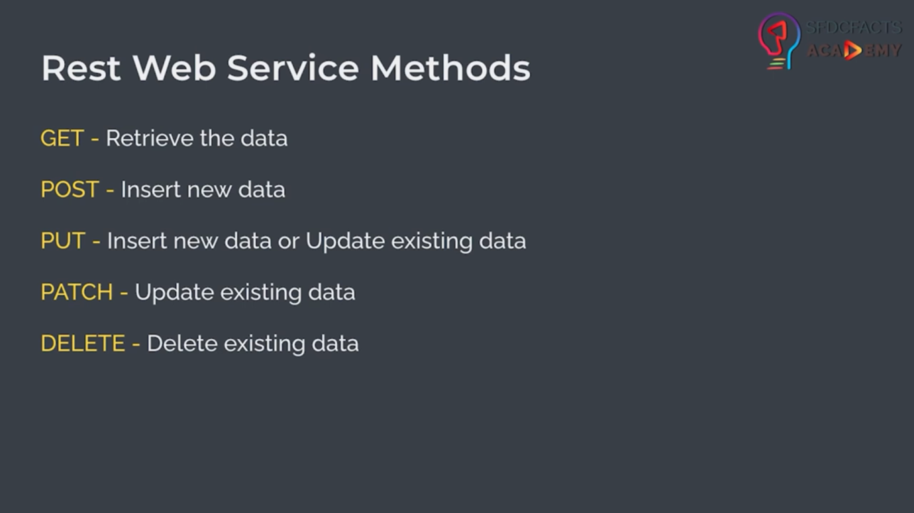

Note: 95% of time, you will use Rest Web Services.

* He explained the Postman API testing through <https://gorest.co.in/> this api portal.
* For creating project 1. He is using <https://spoonacular.com/food-api/docs> for calling api and fetching recipe data.
* He instructed to download Postman app for checking Get API call

-------------------------------------------------------------------------------------------------------------------------------------

* Now, he started making his first project through <https://spoonacular.com/food-api>
* In time stamp of 18:58 to 20:35, he explained about spoonacular api overview.
* In time stamp of 20:35 to 26:45,
  + Recommended to do this module on trailhead, <https://trailhead.salesforce.com/content/learn/modules/apex_integration_services/apex_integration_rest_callouts?trailmix_creator_id=sukritgupta&trailmix_slug=intergration-design>

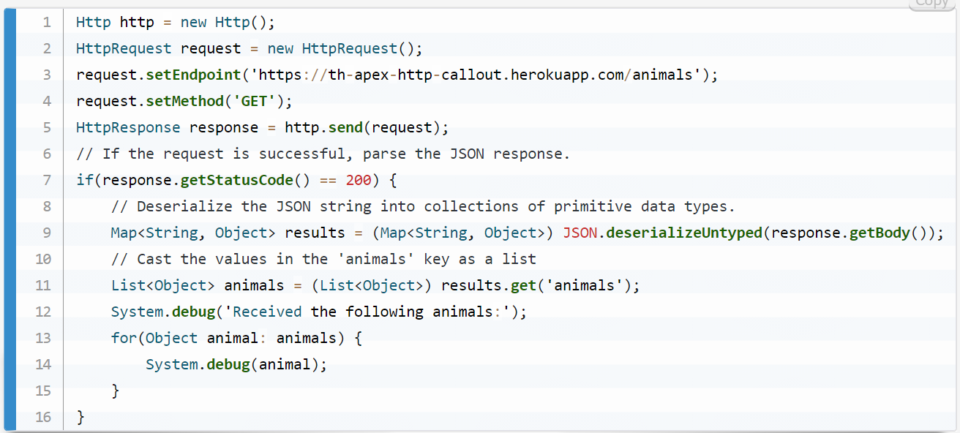

Note: if you have authorization code then you will pass authorization code below request.setMethod().

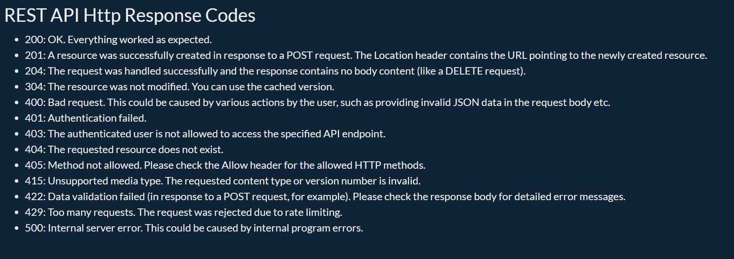

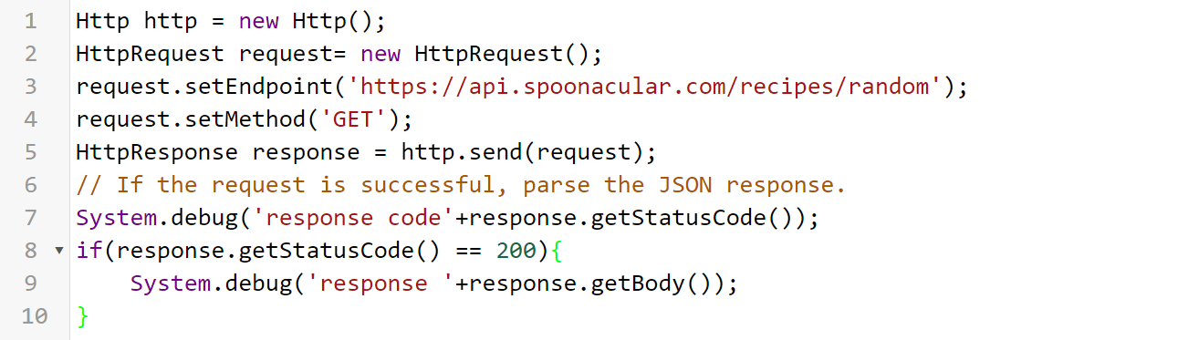

* I was trying to run above integration code in anonymous window but following error message was popup.

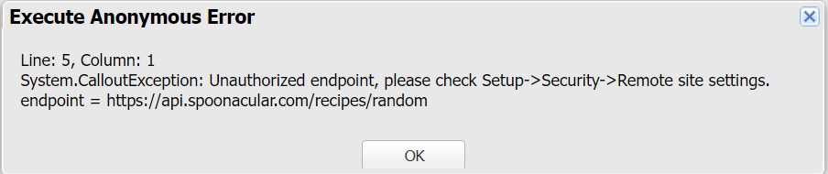 this message is called unauthorized endpoint/ remote site settings error in Salesforce.

Note: if you want to callout any endpoint in Salesforce then you have add endpoint to remote site settings.

* Steps to add endpoint to remote site settings:
  + Setup -> Search for “remote site settings” -> click on remote site settings option
  + After opening of All remote sites then click on “New Remote site” button
  + Enter the server URL inside Remote site URL like in my case <https://api.spoonacular.com>
  + Make it active.

After adding remote site setting, I still get 401 code from server. This code means Authentication failed.

* For solving above Authentication code, I have logged into the spoonacular api portal and go my api key from profile section.
* All the code available inside BugendaiTechAssignmentProject
* Spoonacular class stored all the backend code
* There are two lwc component I made in this project:
  + recipe
  + recipeSearch
* recipeSearch component act like parent of recipe component and passing data into it.

--------------------------------------------------------------------------------------------------------------------------------------

Project – 2 Starts from here: Connect two different Salesforce Org and fetch data from another org

* Create a Rest Webservice in Salesforce Apex: